Date: March 3, 2014
Name of Product: Jabber Guest version 10.0 (Web & iOS application)
Contact for more information: accessibility@cisco.com
The following testing was done on a Windows 7 with Freedom Scientific’s JAWs screen reader v14, Microsoft Accessibility Options (Filter keys and Display/Contrast settings), and standard Keyboard. iOS testing was done on a 4GS, version 7.0.6 (11B651).

Summary Table - Voluntary Product Accessibility Template
Criteria | Supporting Features | Remarks and Explanations
Section 1194.21 Software Applications and Operating Systems | Included
Section 1194.22 Web-based internet information and applications | Included
W3C WCAG 2.0 Level “A” Checkpoints | Included
Section 1194.23 Telecommunications Products | Not Applicable
Section 1194.24 Video and Multi-media Products | Included
Section 1194.25 Self-Contained, Closed Products | Not Applicable
Section 1194.26 Desktop and Portable Computers | Not Applicable
Section 1194.31 Functional Performance Criteria | Included
Section 1194.41 Information, Documentation and Support | Included

Version of the Product

Below is a screen shot of the About screen for Jabber Guest iOS, which states: 1.0.0.412:
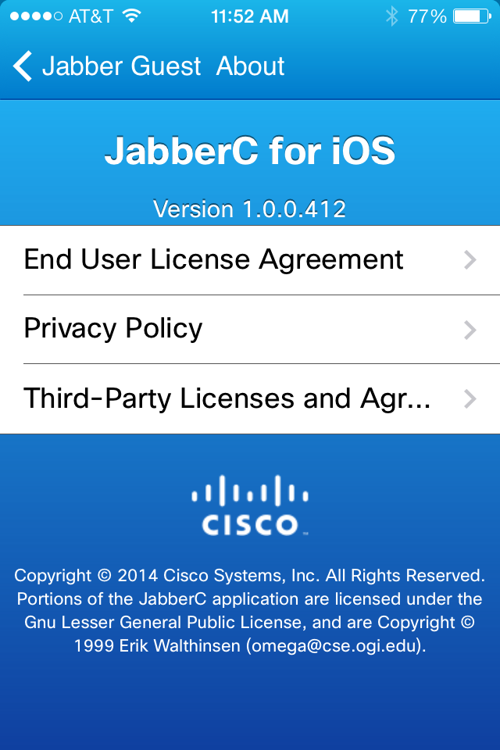

Below is a screen shot of the Jabber Guest Web Settings that has the version # of the product, which states: Jabber Guest: main_10.0.1.58 and Cisco Jabber Guest Plug-in: 10.0.1.11

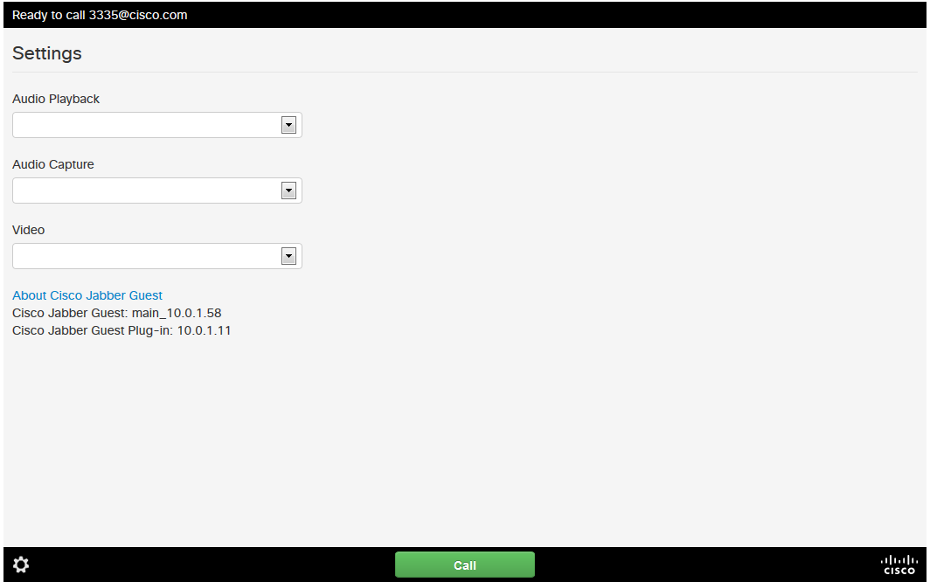

Section 1194.21: Software Applications and Operating Systems – Detail
Cisco Jabber Guest, iOS application
508 Clause | Criteria | Supporting Features | Remarks and Explanations
1194.21(a) | When software is designed to run on a system that has a keyboard, product functions shall be executable from a keyboard where the function itself or the result of performing a function can be discerned textually. | Supports with Exceptions | Assistive Touch issues:  1. Keypad (no close button)  2. Active Video Controls (Call Information, Video Off, Volume, More, Mute, Video, Keypad, End buttons). Time out doesn’t allow the user to send focus to items.
1194.21(b) | Applications shall not disrupt or disable activated features of other products that are identified as accessibility features, where those features are developed and documented according to industry standards. Applications also shall not disrupt or disable activated features of any operating system that are identified as accessibility features where the application programming interface for those accessibility features has been documented by the manufacturer of the operating system and is available to the product developer. | Supports with Exceptions | See 1194.21(f)
1194.21(c) | A well-defined on-screen indication of the current focus shall be provided that moves among interactive interface elements as the input focus changes. The focus shall be programmatically exposed so that Assistive Technology can track focus and focus changes. | Supports with Exceptions | When in an Active Video call, the Controls will timeout (disappear) after 3 to 4 seconds. This feature is setup to have the Video as the primary viewing area and a user must re-invoke the controls to use them.
1194.21(d) | Sufficient information about a user interface element including the identity, operation and state of the element shall be available to Assistive Technology. When an image represents a program element, the information conveyed by the image must also be available in text. | Supports with Exceptions | Issue with VoiceOver label for Volume button. Current spoken label is “Audio Device Button”. Should be “Volume Control Button”.
1194.21(e) | When bitmap images are used to identify controls, status indicators, or other programmatic elements, the meaning assigned to those images shall be consistent throughout an application's performance. | Supports
1194.21(f) | Textual information shall be provided through operating system functions for displaying text. The minimum information that shall be made available is text content, text input caret location, and text attributes. | Supports
1194.21(g) | Applications shall not override user selected contrast and color selections and other individual display attributes. | Supports with Exceptions | 1. The following do not inherit Large text setting: License Agreement, Privacy Agreement, 3rd Party Licenses and Agreement.  2. Poor contrast colors for call information.  Test was done with Invert Colors and Large Text Settings.
1194.21(h) | When animation is displayed, the information shall be displayable in at least one non-animated presentation mode at the option of the user. | Not Applicable
1194.21(i) | Color coding shall not be used as the only means of conveying information, indicating an action, prompting a response, or distinguishing a visual element. | Supports
1194.21(j) | When a product permits a user to adjust color and contrast settings, a variety of color selections capable of producing a range of contrast levels shall be provided. | Not Applicable
1194.21(k) | Software shall not use flashing or blinking text, objects, or other elements having a flash or blink frequency greater than 2 Hz and lower than 55 Hz. | Supports
1194.21(l) | When electronic forms are used, the form shall allow people using Assistive Technology to access the information, field elements, and functionality required for completion and submission of the form, including all directions and cues. | Supports with Exceptions | Active Video Controls (Call Information, Video Off, Volume, More, Mute, Video, Keypad, End buttons). Time out doesn’t allow the user to send focus to items.

Section 1194.22 Web-based internet information and applications – Detail
508 Clause | Criteria | Status | Remarks and Explanations
1194.22(a) | A text equivalent for every non-text element shall be provided (e.g., via "alt", "longdesc", or in element content). | Supports with Exceptions
1194.22(b) | Equivalent alternatives for any multimedia presentation shall be synchronized with the presentation. | Not Applicable
1194.22(c) | Web pages shall be designed so that all information conveyed with color is also available without color, for example from context or markup. | Supports
1194.22(d) | Documents shall be organized so they are readable without requiring an associated style sheet. | Supports with Exceptions
1194.22(e) | Redundant text links shall be provided for each active region of a server-side image map. | Not Applicable
1194.22(f) | Client-side image maps shall be provided instead of server-side image maps except where the regions cannot be defined with an available geometric shape. | Not Applicable
1194.22(g) | Row and column headers shall be identified for data tables. | Supports with Exceptions
1194.22(h) | Markup shall be used to associate data cells and header cells for data tables that have two or more logical levels of row or column headers. | Not Applicable
1194.22(i) | Frames shall be titled with text that facilitates frame identification and navigation. | Not Applicable
1194.22(j) | Pages shall be designed to avoid causing the screen to flicker with a frequency greater than 2 Hz and lower than 55 Hz. | Supports
1194.22(k) | A text-only page, with equivalent information or functionality, shall be provided to make a web site comply with the provisions of this part, when compliance cannot be accomplished in any other way. The content of the text-only page shall be updated whenever the primary page changes. | Non Applicable
1194.22(l) | When pages utilize scripting languages to display content, or to create interface elements, the information provided by the script shall be identified with functional text that can be read by assistive technology. | Supports with Exceptions
1194.22(m) | When a web page requires that an applet, plug-in or other application be present on the client system to interpret page content, the page must provide a link to a plug-in or applet that complies with §1194.21(a) through (l). | Supports with Exceptions
1194.22(n) | When electronic forms are designed to be completed on-line, the form shall allow people using assistive technology to access the information, field elements, and functionality required for completion and submission of the form, including all directions and cues. | Supports with Exceptions
1194.22(o) | A method shall be provided that permits users to skip repetitive navigation links. | Not Applicable
1194.22(p) | When a timed response is required, the user shall be alerted and given sufficient time to indicate more time is required. | Supports

W3C WCAG 2.0 Level “A” Checkpoints – Detail
Checkpoint | Description | Status | Remarks and Explanations
1.1.1 | Non text content | Supports with Exceptions | The starting url page (when users are asked to install the plugin): Cisco Jabber image needs alt attribute (alt=”Cisco Jabber”). This image is on all pages.
1.2.1 | Audio-only and Video-only (Prerecorded) | Not Applicable
1.2.2 | Captions (Prerecorded) | Not Applicable
1.2.3 | Audio Description or Media Alternative (Prerecorded) | Not Applicable
1.3.1 | Info and Relationships | Supports with Exceptions | Settings page:  1) ADR 1.3.1 Use <label for=”…idtext…” for all <select …. > elements. For example:  <label for=”audioPlayout”>Audio Playback</label>  <select id=”audioPlayout” …………>
1.3.2 | Meaningful Sequence | Supports with Exceptions
1.3.3 | Sensory Characteristics | Supports
1.4.1 | Use of Color | Supports
1.4.2 | Audio Control | Supports
1.4.3 | Contrast | Supports with Exceptions | 1) “Cisco Jabber” text is no longer visible  2) Background images like “Settings”, “Cisco” logo (at the bottom) are no longer visible, should be changed to regular images or buttons
2.1.1 | Keyboard | Supports with Exceptions | 1) Feedback page:  The “Close” button is not announced correctly by screen reader software .  I tested by removing attribute aria-hidden="true" then it’s announced correctly. Not sure why the aria-hidden attribute is needed, please investigate.  2) About Cisco Jabber page:  The “Close” button is not announced correctly by screen reader software (similar problem in the Feedback page)Main video plugin page:  3) ADR 2.1.1 The “settings“ toggle button needs to be in the tab order for keyboard and screen reader users. Right now only mouse users can access the settings page. Users should be able to TAB to this button, then press ENTER to load the “Settings” page  4) ADR 2.1.1 The controls of the plugin are visible by mouse over, but they are not accessible by keyboard and screen reader users.  The controls of the plugin are not working with mouse users either (maybe just his version of the code).
2.1.2 | No Keyboard Trap | Not Applicable
2.2.1 | Timing Adjustable | Supports
2.2.2 | Pause, Stop, Hide | Supports
2.3.1 | Three Flashes or Below Threshold | Supports
2.4.1 | Bypass Blocks | Supports with Exceptions | The starting url page (when users are asked to install the plugin): The iframe needs title attribute (for example the installation page use title=”video chat plugin installation”) if this iframe code is reused on other pages title can be generic (title=”main content”)
2.4.2 | Page Titled | Supports with Exceptions | 1. User License Agreement page: HEAD section needs text in title element right now it’s empty (<TITLE>End User License Agreement</TITLE>)  2. End User License Agreement page: ADR 2.4.1 Headings (h1,h2,h3, etc.) should be used on this page to organize the sections/sub-sections of the entire page for screen reader users.
2.4.3 | Focus Order | Supports with Exceptions
2.4.4 | Link Purpose (In Context) | Supports
3.1.1 | Language of Page | Supports with Exceptions | User License Agreement page: HTML element needs lang attribute like Home page (<html lang="en-US">)
3.2.1 | On Focus | Supports
3.2.2 | On Input | Supports with Exceptions | Related to 2.1.1
3.3.1 | Error Identification | Supports with Exceptions | Related to 2.1.1
3.3.2 | Labels or Instructions | Supports with Exceptions | Related to 2.1.1
4.1.1 | Parsing | Supports
4.1.2 | Name, Role, Value | Supports with Exceptions | Related to 2.1.1

Section 1194.24: Video and Multi-media Products – Detail
508 Clause | Criteria | Supporting Features | Remarks and Explanations
1194.24(a) | All analog television displays 13 inches and larger, and computer equipment that includes analog television receiver or display circuitry, shall be equipped with caption decoder circuitry which appropriately receives, decodes, and displays closed captions from broadcast, cable, videotape, and DVD signals. As soon as practicable, but not later than July 1, 2002, widescreen digital television (DTV) displays measuring at least 7.8 inches vertically, DTV sets with conventional displays measuring at least 13 inches vertically, and stand-alone DTV tuners, whether or not they are marketed with display screens, and computer equipment that includes DTV receiver or display circuitry, shall be equipped with caption decoder circuitry which appropriately receives, decodes, and displays closed captions from broadcast, cable, videotape, and DVD signals. | Not Applicable
1194.24(b) | Television tuners, including tuner cards for use in computers, shall be equipped with secondary audio program playback circuitry. | Not Applicable
1194.24(c) | All training and informational video and multimedia productions which support the agency's mission, regardless of format, that contain speech or other audio information necessary for the comprehension of the content, shall be open or closed captioned. | Not Applicable
1194.24(d) | All training and informational video and multimedia productions which support the agency's mission, regardless of format, that contain visual information necessary for the comprehension of the content, shall be audio described. | Not Applicable
1194.24(e) | Display or presentation of alternate text presentation or audio descriptions shall be user-selectable unless permanent. | Does Not Support

Section 1194.31: Functional Performance Criteria – Detail
508 Clause | Criteria | Supporting Features | Remarks and Explanations
1194.31(a) | At least one mode of operation and information retrieval that does not require user vision shall be provided, or support for Assistive Technology used by people who are blind or visually impaired shall be provided. | Supports with Exceptions
1194.31(b) | At least one mode of operation and information retrieval that does not require visual acuity greater than 20/70 shall be provided in audio and enlarged print output working together or independently, or support for Assistive Technology used by people who are visually impaired shall be provided. | Supports with Exceptions
1194.31(c) | At least one mode of operation and information retrieval that does not require user hearing shall be provided, or support for Assistive Technology used by people who are deaf or hard of hearing shall be provided | Supports with Exceptions
1194.31(d) | Where audio information is important for the use of a product, at least one mode of operation and information retrieval shall be provided in an enhanced auditory fashion, or support for assistive hearing devices shall be provided. | Supports
1194.31(e) | At least one mode of operation and information retrieval that does not require user speech shall be provided, or support for Assistive Technology used by people with disabilities shall be provided. | Supports
1194.31(f) | At least one mode of operation and information retrieval that does not require fine motor control or simultaneous actions and that is operable with limited reach and strength shall be provided. | Supports with Exceptions

Section 1194.41: Information, Documentation and Support - Detail
508 Clause | Criteria | Supporting Features | Remarks and Explanations
1194.41(a) | Product support documentation provided to end-users shall be made available in alternate formats upon request, at no additional charge | Supports | Accessible documentation is available through Cisco TAC upon request.
1194.41(b) | End-users shall have access to a description of the accessibility and compatibility features of products in alternate formats or alternate methods upon request, at no additional charge. | Supports | Accessible documentation is available through Cisco TAC upon request.
1194.41(c) | Support services for products shall accommodate the communication needs of end-users with disabilities. | Supports | Cisco conforms through equal facilitation. Customers may reach Cisco Technical Assistance Center (TAC) via Phone, Email or Web Form. All cases open through email or web are opened as Priority 3 cases. All Priority 1 or Priority 2 case can only be opened via the telephone. TTY users must call the Text Relay Service (TRS) by dialing 711 or their state Video Relay Service (VRS) and have the TRS agent contact Cisco TAC via voice.

